
ICT80004 Final Internship Project Review Form - Close

Student Name: Arun Ragavendhar Arunachalam Palaniyappan

ID: 104837257

Organisation: Commonwealth Scientific and Industrial Research Organisation (CSIRO)

Industry Supervisor:
Dr. Shigang Liu
Date: 22/10/2025

Rate your current level of knowledge on the following by ticking on the appropriate box. (Complete this in consultation with your industry supervisor)

Your perception  Knowledge | I can teach and share this to my  colleagues | I know more than enough | I’m happy with what I know | I want to learn more about this | I like to have help on this
1. awareness of a range of issues  associated with professional practice |  |  |  |  | 
2. professional and personal skills |  |  |  |  | 
3. practical skills and theoretical  knowledge into an IT industry context |  |  |  |  | 
4. understanding of business processes  and organisational structures |  |  |  |  | 
5. professional contacts and networks  within the IT industry |  |  |  |  | 

Student’s Comments:

Over this internship with CSIRO’s Data61, I moved from research to repeatable practice across three streams: (1) Code safety—a one-file C demo that shows bad vs fixed memory behaviour; I also tested 12 common bug types with 4 prompting styles and recorded outcomes. (2) Text prompts—a 325-prompt set (direct and reworded) across nine tactics, placed at the start, middle, and end of a message; a small R check kept the sheet clean (duplicates, near-dups, mismatched decisions) so comparisons were fair. (3) Pattern tests (FPA)—small changes to familiar tasks that reveal when a model “assumes” a path ran while the program shows it didn’t. All outputs—logs, screenshots, tables, and code—are reproducible and versioned in a shared repository. Professionally, I kept weekly updates, clear notes, on-time deliveries and weekly meetings with my industry supervisor; technically, I improved experiment design, data quality checks, and safe-coding habits. Why this matters to the community: AI is now part of daily life—this work helps catch prompt-based pitfalls early, reducing unsafe advice and making guardrails practical. My vision: open, checkable tools that help teams ship AI-backed features safely and responsibly, and that the community (students and engineers) can reuse and extend. Next time, I will set scope earlier and share more hands-on tasks across the team to create extra learning opportunities. Overall, I can explain risks plainly, show proof others can re-run, and recommend simple steps teams can adopt right away—meeting unit learning outcomes on professional practice, skills growth, industry application, process awareness, and networks.

Specific Examples of work done over last 6 weeks
- Week 12 (20–24 Oct): Finalised the slide deck and one-pager; packaged the one-file C demo with screenshots and logs → reviewer can follow without extra context.
- Week 11 (13–17 Oct): Ran AddressSanitizer/UBSan bad vs fixed evidence on stack-overflow cases → clear before/after proof for bounds and destination-sized copies.
- Week 10 (6–10 Oct): Executed FPA single- and multi-case runners (vowel check, nth-prime off-by-one, in-range, to-cents) → repeatable misreads with saved outputs.
- Week 9 (29 Sept–3 Oct): Cleaned the 325-prompt sheet using the R check (duplicates, near-duplicates, leakage, agreement) → fair comparisons across models.
- Week 8 (22–26 Sept): Re-ordered slides to tell a simple story (problem → methods → evidence → adopt-now steps) → clearer discussion in reviews.
- Week 7 (15–19 Sept): Expanded the dataset and coverage grid; set the logging schema and result labels; drafted the evaluation rubric/checklist; organised the repo layout → consistent data capture and easier comparisons for Weeks 8–12.

Industry Supervisor’s Comments:
Arun has shown strong dedication, curiosity, and technical skill throughout the internship at CSIRO’s Data61. He worked hard, learned quickly, and successfully completed all assigned tasks with high quality and professionalism. His work on code safety, structured prompt evaluation, and pattern testing was systematic, reproducible, and well documented. He demonstrated the ability to connect theoretical understanding with practical application, communicate results clearly, and work independently. Overall, he performed exceptionally well, showing excellent growth and strong potential for future research or industry roles.

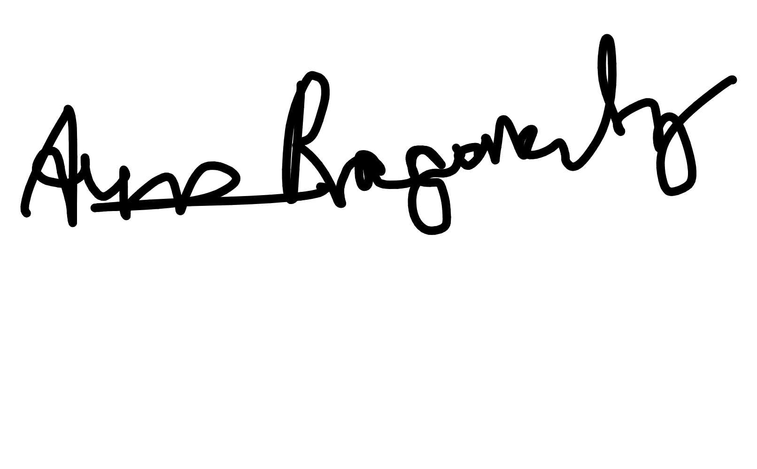
Student Signature: Date:
Digitally signed by e6946984- aaa8-4280-8911-ef2eebc1142c Date: 2025.10.22 09:57:16 +11'00'

Supervisor Signature: Date:
Shigang Liu
Digitally signed by Shigang Liu Date: 2025.10.22 14:03:15
+11'00'
22/10/2025

22/10/2025

ICT80004 – Final Internship Project Review Form

Evidence of timely communications to both academic supervisor and Industry supervisor for arranging the meeting and completing the final review.

Email Screenshots to Industry Supervisor (Dr. Shigang Liu) asking for comments and
Signature and availability timings for scheduling the final review meeting.

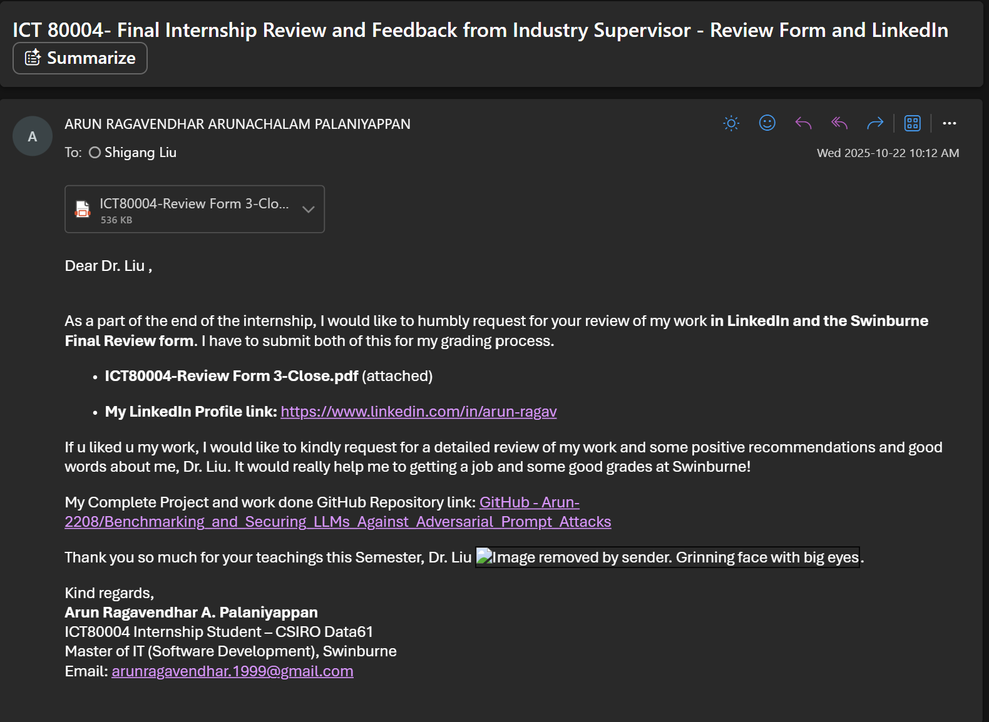

Email Screenshots to Academic Supervisor (Dr. Bita) to check availability timings for scheduling the final review meeting.

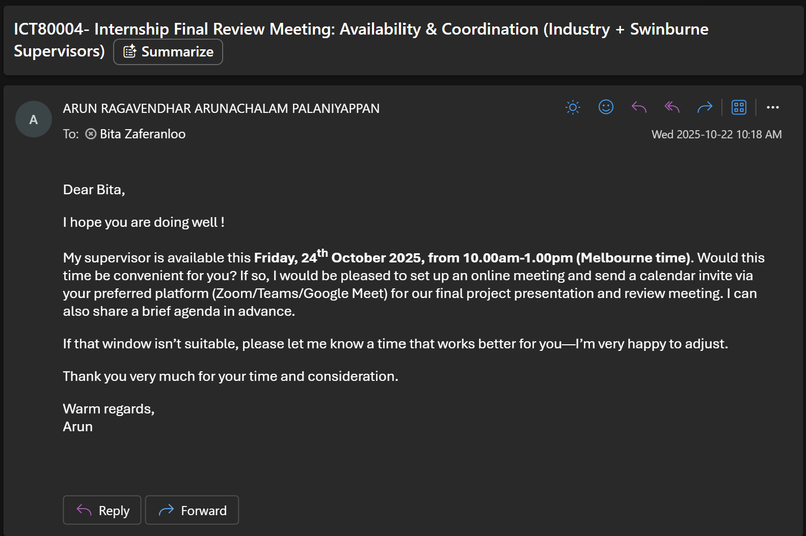

Final review meeting was scheduled and it was finished successfully.

